Multiple choice section

Question 1 [9.2]

What is the median of the following numbers? 4 4 6 5 8

A 4 B 5 C 5.4 D 6

Question 2 [9.2]

The following column graph shows the favourite football team for Year 7 students.

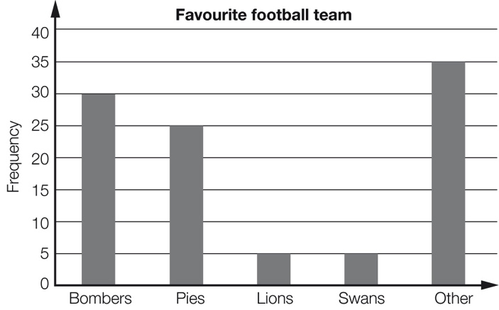

The approximate percentage of students who support the Pies or the Lions is:

A 5 B 20 C 25 D 30

Question 3 [9.7]

A normal die is rolled once. The probability of rolling a multiple of 3 is:

A  B  C  D 2

Question 4 [9.4]

The best type of statistical graph to display the brand of car owned by a selection of 100 car owners is a:

A sector graph B line graph C histogram D stem-and-leaf plot

Question 5 [9.2]

What is the mean of the following data? 2 2 3 5 8 10 12

A 2 B 5 C 6 D 7

Question 6 [9.1]

The following data list records the street address numbers for each of the students in a class.

|  |  |  |  |  |  |  |  |
| --- | --- | --- | --- | --- | --- | --- | --- |
| 28 | 44 | 59 | 3 | 148 | 90 | 82 | 16 |
| 21 | 18 | 21 | 45 | 36 | 20 | 45 | 77 |
| 2 | 15 | 18 | 19 | 25 | 40 | 43 | 111 |

The frequency for the 11−20 group is:

A 4 B 5 C 6 D 7

Question 7 [9.7]

When Victor and Brenda played Scrabble in the past, Victor won 6 games and Brenda won 5. The probability that Victor will win the next game is:

A 54% B 46% C 45% D 55%

Question 8 [9.4]

In one class, 46% of students have brown hair. If a sector graph is to be drawn showing hair colour, then the number of degrees required for brown hair is:

A 46° B 54° C 83° D 166°

Question 9 [9.5]

Rhonda has a 5000 L water tank that she uses to water her vegetable garden. The graph shows the amount of water in the tank at the beginning of the week for a 12-week period.

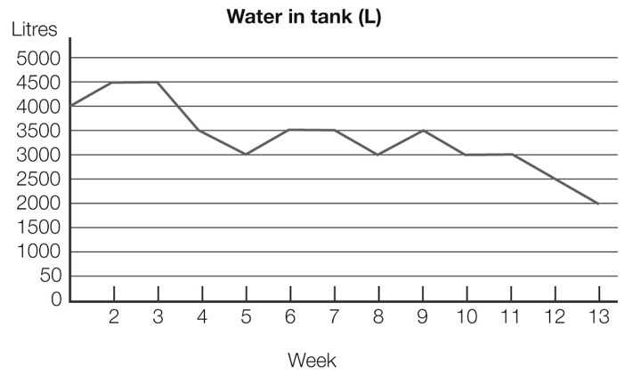

In which weeks can you be certain there was rain?

A 5, 10 and 11 B 4, 7 and 8 C 3, 6 and 7 D 1, 5 and 8

Question 10 [9.4]

The graph below shows the percentage contribution of various activities to Australia’s greenhouse gas emissions. Agriculture and transport together contribute:

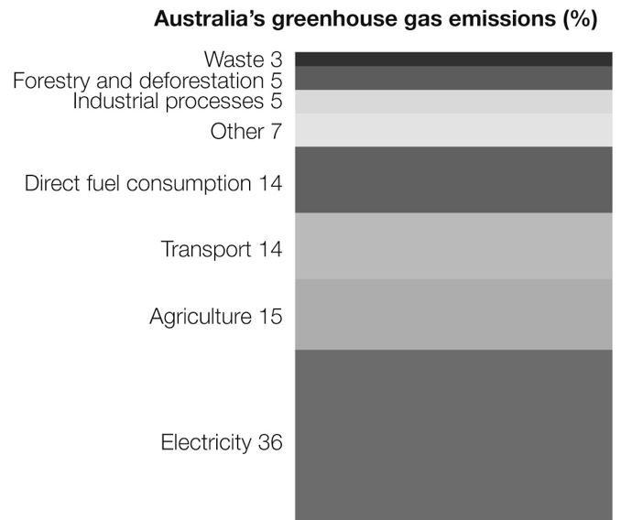

A 14% B 15% C 29% D 36%

Question 11 [9.2]

What is the mode of the following numbers? 1, 3, 5, 3, 4, 2, 3, 1, 4, 2

A 1, 2 and 4 B 3 C 10 D 28

Multiple-choice total marks: ____ / 11

Short answer section

Question 12 3 marks [9.1]

Use words from the list below to complete the following sentences.

bivariate data categorical data mean median probability sample space

(a) The ______________ of a data set is found by adding together all the results and dividing by the number of results.

(b) The ________________________ of an event is found by dividing the number of successful outcomes by the total number of outcomes.

(c) If we record the colour of cars in a car park we are dealing with _______________________ .

Question 13 2 marks [9.1]

Explain the difference between continuous numerical data and discrete numerical data. Give an example of each to help you explain the difference.

Question 14 5 marks [9.3]

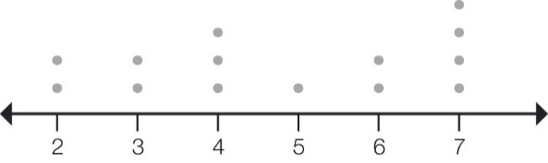

For the dot plot above find:

(a) the mean (correct to 1 decimal place)

(b) the median

(c) the mode

(d) the range.

Question 15 4 marks [9.5]

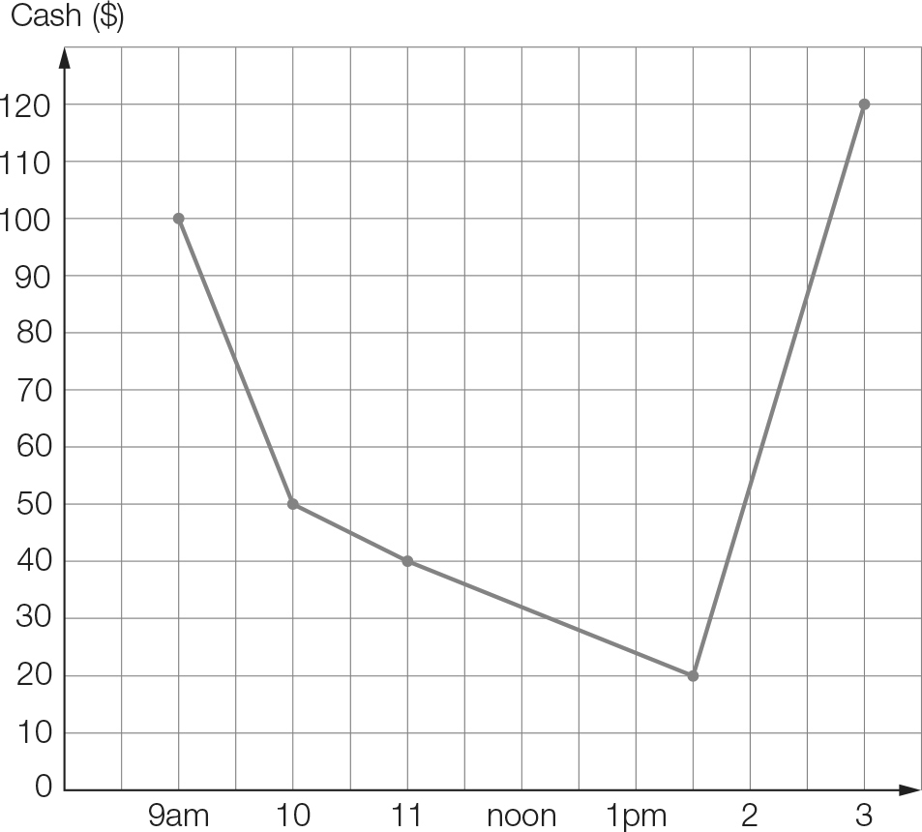

Joanie went to the shopping mall at 9 am with $100 in her wallet. She recorded the amount of money in her wallet following each transaction.

(a) What was the largest amount that Joanie spent and when was this?

(b) At what time did Joanie go to the cash point? How much did she withdraw?

(c) For what period of time did Joanie have $40 in her wallet?

(d) For what period of time did Joanie have less than $80 in her wallet?

Question 16 4 marks [9.3]

A class of year 7 students kept a tally of the number of movies they saw throughout the term. Here are their results.

25 37 15 12 5 40 31 43 22 14 27 38

19 26 8 25 19 11 10 20 44 9 6 26

(a) Construct an ordered stem-and-leaf plot to show the data using stems of 0, 1, 2 etc.

|  |  |
| --- | --- |
| STEM | LEAF |
|  |  |
|  |  |
|  |  |
|  |  |
|  |  |

(b) Describe the distribution of data using median and range.

Median:

Range:

Description of data:

Question 17 4 marks [9.4]

A report on speeding fines in Victoria showed that of the average of about 3500 fines every day, 2530 were for drivers going less than 10 km/h over the limit, 962 were for going more than 10 but less than 20 km/h over the limit, and 8 were for going 20 km/h or more over the limit.

(a) If you were to draw a pie graph of these categories, what angle would represent drivers fined for going less than 10 km/h over the limit?

(b) If a divided bar chart was used, what would you make the total length, and what length would represent drivers between 10 and 20 km/h over the limit?

Question 18 5 marks [9.6]

The average monthly maximum temperatures are given for two cities in Australia. Compare the temperatures of the two cities from the graph using the the median and range for each city.

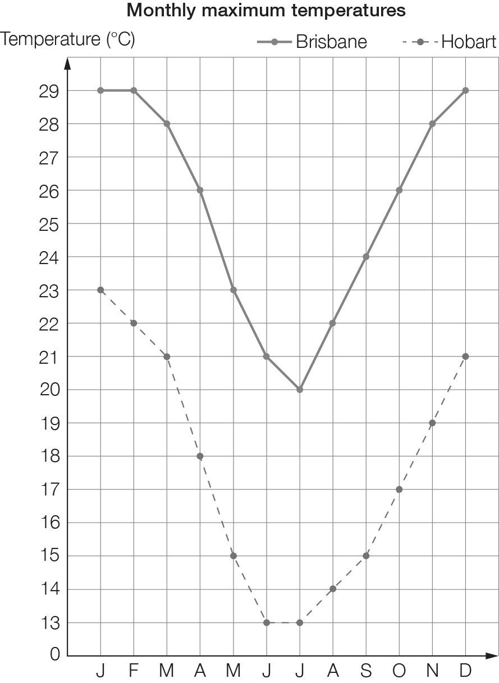

Medians for two cities:

Ranges for two cities:

Comparison of data:

Question 19 7 marks [9.7]

A large spinning wheel is constructed and is divided into 20 equally sized sectors numbered from 1 to 20. The wheel is spun once. Find the probability of each of the following events.

(a) The spinner lands on 15.

(b) The spinner lands on a multiple of 5.

(c) The spinner lands on a multiple of 9.

(d) The spinner lands on a prime number.

(e) The spinner lands on a multiple of 3 or a multiple of 6.

Short answer total:_________/34

Extended answer section

Question 20 7 marks [9.1, 9.2, 9.3]

The Year 7 class has been training for the Athletic Sports. Each student ran the 100 m and had their time recorded. This was written in seconds to the nearest tenth of a second. The times were:

12.6 13.1 11.9 13.0 12.6 12.7 13.1 14.0 13.8 12.5 12.6 12.7 13.6

14.3 14.4 14.0 12.9 13.0 14.2 13.7 13.3 12.7 13.5 11.9 14.0

(a) Is the data discrete or continuous?

(b) Complete the frequency table.

|  |  |  |
| --- | --- | --- |
| Class interval | Tally marks | Frequency |
| 11.5−<12.0 |  |  |
| 12.0−<12.5 |  |  |
| 12.5−<13.0 |  |  |
| 13.0−<13.5 |  |  |
| 13.5−<14.0 |  |  |
| 14.0−<14.5 |  |  |
|  |  |  |

(c) Construct a frequency column graph to show the data.

(d) What percentage of students ran a time better than 13.0 seconds?

Question 21 4 marks [9.6]

Students in Class 7A were asked: ‘If you could have only one pet, what would it be?’ The results were as follows: cat 10, dog 8, bird 4, fish 2, other 1.

(a) If you drew a divided bar graph of the data, what height would it be?

(b) What length would you need to represent ‘dog’?

(c) If a student from 7A is chosen at random, what is the probability that their choice of pet is ‘cat’?

Question 22 9 marks [9.7]

A game consists of spinning a spinner that is divided into five equal parts (two coloured red, two coloured green and one coloured blue), as well as rolling a standard six-sided die.

(a) Complete the table to show the sample space.

|  |  |  |  |  |  |  |
| --- | --- | --- | --- | --- | --- | --- |
|  | 1 | 2 | 3 | 4 | 5 | 6 |
| **Red1** | (R1, 1) | (R1, 2) | (R1, 3) | (R1, 4) | (R1, 5) | (R1, 6) |
| **Red2** | (R2, 1) |  |  |  |  |  |
| **Green1** | (G1, 1) |  |  |  |  |  |
| **Green2** | (G2, 1) |  |  |  |  |  |
| **Blue** | (B, 1) |  |  |  |  |  |

(b) What is the probability of spinning blue and rolling an even number?

(c) What is the probability of spinning red and rolling an even number?

(d) Steve and Terry play a game where Steve wins if he spins blue and rolls an even number, but Terry wins if it is red and even. Is this a fair game? Explain your answer.

(e) Make up the rules for a fair game that could be played with this die and spinner.

Extended answer total:_________/ 20

TOTAL test marks: _______ / 65